JUDICIAL RESOLUTION OF CASES IN SMALL SCALE FINANCIAL CLAIMS:
THE MALAYSIAN EXPERIENCE

Glenda E. Feliprada, M.A., Ll.b. Phd (Cand.)
Prof. Jayum Anak Jawan, Phd (Hull)
Universiti Putra Malaysia, Faculty of Human Ecology
Serdang Selangor, Malaysia

ABSTRACT

The Small Claims Procedures adopted in Malaysia underwent extensive amendments under Order 93, Rules of Court 2012 that refined mechanism in its 32 years in implementation since 1980 it was first adopted.

The Small Claims Procedures enable individual creditors to institute proceedings without legal counsel for claims less than RM 5,000.00 (USD 1,168.91) Its procedure is commended for its simplified mechanism, as well as fast and low of cost of litigation. The presiding magistrate adopts inquisitorial system and substantial evidence to grant resolution fair and equitable to parties.

The Malaysian’s Small Claim Procedures is a civil case distinctly implements warrant of arrest and imprisons the defendant for failure to comply with the court order.

The average disposition duration of case is 71.1 days (2.38 months) from registration to resolution. The case resolution on judgment default at 40.8% is a challenge to solve the public awareness of Small Claims Procedures.

JUDICIAL RESOLUTIONS OF CASES IN SMALL SCALE FINANCIAL CLAIMS:
THE MALAYSIAN EXPERIENCE

CONTENT

The methodology adopts both qualitative and quantitative analysis in the assessment of the Malaysia Small Claims Procedures in the disposal rate of cases covering Kuala Lumpur, Sha Alam and Johor Bharu District Court. The interviews were conducted face to face with presiding magistrates, court personnel and litigants to evaluate the efficiency and effectiveness of the procedure.
The study addresses the gap between the policies and the experience of the end user of the Small Claims Procedures.
Malaysia is among the countries in Southeast Asia which implemented the Small Claims Procedure in 1980, amended in 1987 and 2012, Rules of Court, and Order 93. This is purposely to enable individuals institute legal proceedings to claim for money amounting to less than RM 5,000.00 (US$ 1,168.91) without the need for a solicitor or advocate. (Order 93.7.2, Rules of Court 2012 Malaysian Court Practice).

The plaintiff is the aggrieved individual, not an agent or assignee of any debt of another person. The claim covers the refund of money paid for goods which turn out to be defective; wages/salaries for work not paid; and claims for commissions; payment of services rendered; facilities supplied, or repairs undertaken. It is under the jurisdiction of the Magistrate Court.

The Small Claims Procedure was the initiative of a progressive judicial system to ensure equity justice to the less advantaged and marginalized in the society which is also adopted in other countries like Philippines, Indonesia that originated from European and eventually adopted by American countries. The procedure was commended for its simplified mechanism, as well as fast and low cost litigation of cases. The magistrate is a mediator conducting the inquisition which he ascertains that evidence presented is substantial to establish the claim ensuring fairness for parties. The magistrate grants ample time for both parties to present evidence in court, requires additional evidence necessary and facilitates resolution. Parties are given latitude to express and defend themselves in court without observing strict court rules applied in regular civil cases. The magistrate uses the local dialect in facilitating court proceedings as well as raising clarification questions.

The Small Claims Procedures court litigation commences upon the filling by plaintiff of form 198 in four copies to the Registry and payment of the prescribed fee. It takes effect when the registered post addressed of the defendant is received. The defendant, upon receipt of Form 198, responds in Form 199 filed in four copies within fourteen days after getting the claim. The defence form contains the reason for the defendant’s dispute of the claim. He can file a counterclaim which states the amount of the debt and particulars duly signed or thumb printed. The service form 199 takes effect upon receipt of the registered post addressed to the plaintiff. The plaintiff may dispute Form 199 of the defendant, file a defence to the counterclaim in Form 200 for which a copy of the form is required to be served to the defendant. (Order 93.6.1-5, Rules of Court 2012 Malaysian Court Practice).

Where the defendant fails to file his defence in Form 199 within 14 days after the receipt of the claim, the plaintiff can request for judgment in default of the defence on the hearing date. The court may enter the default judgment in Form 201 to the plaintiff after the 14 - day period that the defendant has been duly served with the plaintiff’s claim and failed to file his defence within the period. However, defendant may apply for an adjournment of the hearing date before the expiration of the 14 day period to file his defence due to short notice of the claim or for some other reasons. The court exercises its discretion to grant an adjournment in the interest of justice and fairness to for the defendant to enter his defence. (Order 93.8.1-3, Rules of Court 2012 Malaysian Court Practice).

The court gives judgment to the plaintiff in Form 202 upon failure of the defendant to attend the hearing. However, in the absence of the plaintiff during the hearing while the defendant is present empowers the court to declare judgment in behalf of the defendant noted in Form 203. Upon defendant’s admission of the response in the statement of defence, the judgment enters noted in Form 204. (Order 93.9.2, Rules of Court 2012 Malaysian Court Practice).

In any judgment or order obtained where one party does not appear at hearing, the court sets aside the application of the aggrieved party in Form 205 on such terms the Court perceives as just. The application of this rule should be made within 21 days from the service of the judgment or order. The aggrieved party can apply for an extension if he filed out of time, which the court grants at its discretion. Every judgment or order shall be served to the person to whom it was addressed by registered post by the court. The purpose of the rule is to give the defendant the opportunity to apply to set aside judgment or order; or for the party in whose favour the judgment or order was made to proceed for execution of decision where the person to whom the judgement or order was served fail to comply. (Order 93.10.3, Rules of Court 2012 Malaysian Court Practice).

The Court shall, where possible, assist the parties to effect the settlement of a case by consent. The judgment is obtained by consent as contained in Form 206. Otherwise, the Court proceeds to hear the case and gives a decision thereon. The Court may also choose to adjourn to another date for final disposition, and the judgment to be made after a hearing as indicated in Form 207. (Order 93.13.1-3, Rules of Court 2012 Malaysian Court Practice).

The Court has the power to seek further information to consider documentary or other evidence in the hearing of the case when deemed necessary to evaluate all evidence before making a decision. The court exercises its discretion to award not exceeding one hundred ringgit (RM 100) to the aggrieved party. However, the cases parties consulted an advocator or authorized representation in court. The legal fees of an advocator shall not be allowed in the Small Claims procedure. (Order 93.15.1-2, Rules of Court 2012 Malaysian Court Practice).

In cases of failure of debtor to comply the judgment; the creditor can apply in court for its enforcement in Form 208 a notice to show cause, duly signed or thumb printed and signed by the magistrate. This service of notice need to personally or prepaid registered post addressed to the debtor’s last known address. This requires debtor to appear in court on the date specified and indicate reason that enforcement of the judgment or order should not be made against him. (Order 93.16.1-3, Rules of Court 2012 Malaysian Court Practice).

The notice requires the debtor to deposit in court the sum in cash or a money order in the name of the creditor within ten days of the receipt of the notice. Upon the completion of the cash deposit, the debtors appearance in court is not needed it is considered satisfaction of the court judgment order. In cases, failure of the debtor to settle the debt within the ten-day period, he is required to appear in court on the date stated in the notice; and subsequent failure to comply with court notice a warrant for arrest shall be issued. In court, the judgment or order be enforced with the following courses: (1) order a writ of seizure and sale to be issued in Form 84; (2) allow him time to settle the debt; (3) allow him to pay the debt by instalments; or (4) order him to be committed to prison and shall be released thereof upon full payment of the judgment order. (Order 93.11.1-2, Rules of Court 2012 Malaysian Court Practice).

This sanction is relatively stern in comparison to the Small Claims Cases covering civil cases among other countries. This system is in line with the Islamic teaching of the full responsibility of a person to render full payment of debt to others. (Yahya, 2017) It can be perceived as beneficial to the plaintiff as the state protects and secures payment of the obligation as per court order. The arrest and imprisonment mechanism in a civil case creates a serious impact on the Malaysians. This provision presents a decisive factor for parties to comply with the court judgment and enforce the right to claim a minimal amount in civil disputes.

The Small Claims Cases in most countries do not include imprisonment for failure to comply with court order. Instead, the plaintiff files the writ of execution in court for failure to pay and by court order, garnishment of personal property to settle the obligations of the defendant in Small Claims Cases except in the case of Indonesia the unresolved Small Claims Cases will be reverted to regular civil courts proceedings.

FINDINGS

The magistrate judges and court personnel of Kuala Lumpur, Sha Alam and Johor Baru claimed that awareness level of the public on Small Claim Procedures is still limited to those who are party litigants referred by lawyers and acquaintances of the court personnel. There is a need to intensify information dissemination through television, and radio which would be beneficial to the public as this eventually informs Malaysian citizens in the Peninsula especially those in remote areas. The Sha Alam magistrate recommended that the claim of RM 5,000.00 (US $ 1,168.91) be increased to RM 10,000.00 – 20,000 (US$ 2,337.81 - $4,675.63) to cover the rise of the standard of living in Malaysia. It was pointed out that separate specialized Small Claims Court would increase efficiency in addressing the debt servicing. It requires more time for the magistrate instead of merging the criminal and civil cases that are complicated and delicate.

Photo 1 Interview with the Magistrate of Sha Alam and Plaintiff
with the assistance of the Court Interpreter

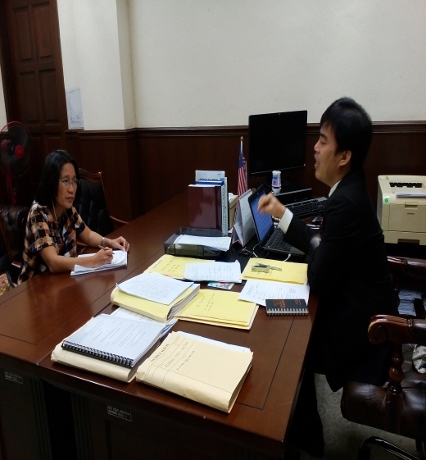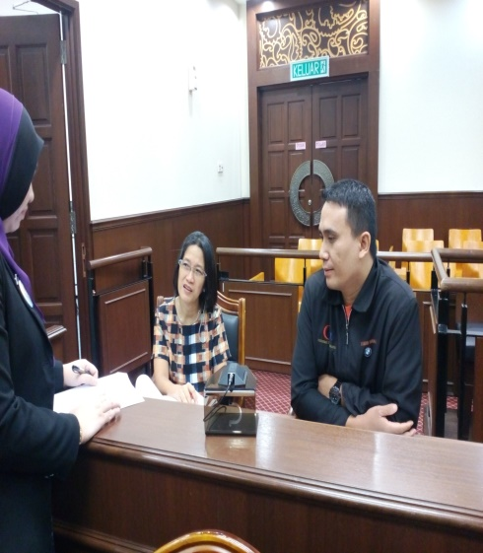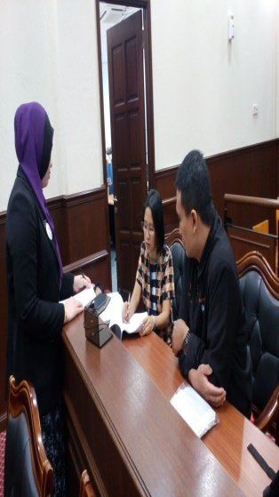
Source: Photo is the courtesy of Sha Alam Court of Staff
Table 1 Court Resolution on Small Claims Selected Ares in Malaysia Percentage (%)
Magistrate Courts | Compromise  % | Judgment Default  % | Decision on Merits  % | Total  %
Malaysia | 22.9 | 40.8 | 36.3 | 100.0
Kuala Lumpur | 4.1 | 44.3 | 51.6 | 100.0
Sha Alam | 39.3 | 46.4 | 14.3 | 100.0
Johor Bharu | 54.3 | 25.7 | 20.0 | 100.00
Source: Magistrate Court Cause Book Print, Kuala Lumpur, Sha Alam, and Johor Bahru
2014-2015
Table 1 shows the percentage of court resolution by outcome of Malaysia on Small Claims Procedure from three magistrate courts of Kuala Lumpur, Sha Alam. and Johor Bahru.

The resolution of cases is categorized into compromise, judgment in default and decision based on the merits of the case. The court magistrate encourages parties to settle civil claims through compromise agreement and explained its advantages and disadvantages. Judgment in default is resolved by the court upon failure of parties to attend sessions with proof service of summons. Whereas decision on merits is meted by the magistrate upon failure of parties to arrive with compromise agreements, this is based on the equity of court judgment consistent with the prevailing rules, and contract not contrary to law.

In Johor Bahru, more than half (54.3%) of cases were resolved by compromise agreement. In Kuala Lumpur, decision on merits consolidated more than half of the decision (51.6%) and in Sha Alam (46.5%) of cases was resolved through judgment default.

Majority of cases in Johor Bahru were resolved through compromise agreement are attributed to magistrates efficiency in providing a comprehensive explanation of conciliatory settling among parties. The negotiation is the easiest way to buy peace and resolve differences payment of paying in instalment through affordable and acceptable conditions is sought. This shortens time for the parties to attend court hearings. The willingness and flexibility of the parties to address the conditions proposed by the magistrate are essential for amicable settlement of the civil obligations.
However, in Kuala Lumpur majority of the cases are resolved through decision on merits. Since the court case load is high and time constrains the facilitation of more time for accommodating the parties for compromise agreement which the plaintiff resists. Most corporation defendants are represented by lawyers the authorized representatives, provided by the Rules of Court 2012. They stretch the maximum time allowed in legal litigation of civil obligations for the magistrate decision on the merits.

The Sha Alam magistrate’s highest case resolution is through judgment default. In an interview with the plaintiff, he claimed that his defendant a corporation failed to attend hearings because of the inconvenience and preferred to wait for court orders rather than appear in court since it perceived that judgment in favor of the plaintiff. The defendant submits to theory that they are bound to abide by court order and failure to follow means a warrant of arrest.

The parties in Small Claims Procedure’s primary concern is to receive monetary remuneration for their claims without regard of the mechanism process either by compromise agreement, judgment default or decided based on the merits. It does not have any impact. The parties perceived the court as a collection agency to enforce their claims.
This reflects that the public is not aware of the principle of the Small Claims Procedures that needed to be address by the state to ensure that the procedure is not only efficient but essentially it is also effective mechanism of addressing merger financial obligations of the public.
In this regard, court resolutions are based on the circumstances of the parties to enter into easiest and fastest compromise dependent on the parties’ willingness to settle in an acceptable condition. However, the absentee defendant tests the plaintiff endurance to wait for the prescribed time to be compiled which is the major factor for delays. Whereas, decisions based on merits that magistrate makes are based on the circumstances and applicable laws fair for the parties, upon their failure to agree on compromise between themselves.
Figure 1. Comparison of Court Resolution of Kuala Lumpur, Sha Alam and Johor Bahru
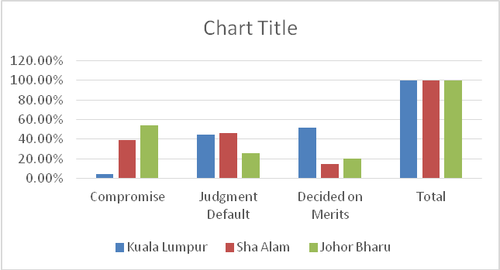
Source: Magistrate Court Cause Book Print, Kuala Lumpur, Sha Alam, and Johor Bahru
2014-2015
Figure 1 shows the percentages of court resolution in Kuala Lumpur, Sha Alam and Johor Bahru, 2014-2015. Judgment default at 40.8% percent is highest in Sha Alam which means majority of the defendants fail to appear in court and waived the opportunity to seek better options for payment such as installment as well as the affordable terms.
Kuala Lumpur’s court decision on merits is the highest at 51.6% percent wherein the magistrate gives the verdict based on the circumstance defined by the statute and mandate for the parties to abide where the court order is non appealable. The parties’ failure to comply is sanctioned with warrant of arrest or imprisonment and released upon full payment of the monetary obligations. This is enforced in Malaysia with outmost humane considerations that warrant of arrest and imprisonment are used as the last resorts to compel payment.
The mechanism is viewed as punitive in civil case disputes. Non-imprisonment for non-payment of debt is regarded as infringement of the constitutional rights in most countries.
Kota Kinabalu’s highest court resolution at 54.3% is based on compromise agreement of the parties, installment payment, reasonable terms in the amount affordable to the defendant and the date of payment convenient to the parties as set by the court. This mechanism has commendable results to the parties to re-build strained relationship among members of the family and revive confidence between debtors and creditor. The most significant effects that public impression of the magistrate as a rational, humane, and considerate individual to settle conflicts in society. In the interviews with magistrates they consider as the most fulfilling job in the judiciary seeing parties leaving the court contented, restored relationships and settlement of issues amicably with light hearted and cool headed people instead of seeing one party imprisoned for unfulfilled civil obligations.
Table 2. Types of Resolutions for Sum of Money in Kuala Lumpur
Individual Defendant % |  |  | Corporation Defendant %
Compromise | Judgment Default | Decision on Merits | Compromise | Judgment Default | Decision on Merits
10 | 47 | 43 | 7 | 39 | 54
Source: Magistrate Court Cause Book Print Kuala Lumpur, 2014-2015

Table 2 shows comparison resolution with only 10% percent; and 47% percent, judgment default where the magistrate resolved cases in the absence of the plaintiff or defendant despite written notice. Magistrate resolve 43% percent of cases based on merits.

The corporation defendant submits only 7% percent into compromise, 39% percent was on judgment default, magistrate resolves case in case plaintiff or defendant failed to appear despite written notice and the highest at 54% percent the magistrate resolves the case on based on the merits of the case.

In an interview with the Magistrate Court of Kuala Lumpur, compromise agreement is the least mentioned among parties in Small Claims Cases primarily due to the pre-conceived opinions of plaintiff that court litigation is to get even with the defendant for the frustration and treatment experienced from the defendant. The aggrieved party desist compromise agreement and instead insists to submit to the litigation process at the cost of time and the expense of attending hearing. The time constraint is a factor that compromises agreement is lowest since Kuala Lumpur is highly urbanized where case load is high compared to other states with lower caseloads. The magistrate has no sufficient time for convincing parties into settlement since the Small Claims Cases are calendared in court together with other Civil Cases. Among individual and corporation defendants, it is the former that is difficult to convince to compromise compared with lawyers who are authorized representatives of the corporations. This litigation proceeding, resolved at an average of 60 days from the filing of the case and the shortest time of resolving cases is 21 days and the longest litigation 378 days.

In corporations as defendant, most are represented by authorized advocates whose knowledge of litigation is an advantage against an individual plaintiff who relied solely on magistrate’s interventions to receive favorable judgment. The Magistrate Court of Kuala Lumpur is strategically located at the business district and accessible to public transportation. The accessibility of the court of the public in attending magistrate sessions as frequent as court requires to the parties is not seen as hindrance since it is in a highly urbanized venue. Whereas, Sha Alam and Johor Bahru. Magistrate courts are remote from public transportation and far from the business center and seen as disadvantage to the public.

Table 3 Types of Defendants in Resolution for Sum of Money
in Sha Alam Percentage (%)

Individual Defendant (%) |  |  | Corporation Defendant (%)
Compromise | Judgment Default | Decision on Merits | Compromise | Judgment Default | Decision on Merits
46 | 42 | 12 | 47 | 34 | 19
Source: Magistrate Court Cause Book Sha Alam, 2014-2015

Table 3 shows that 46% individual defendant submit to compromise with the plaintiff, 42 % percent, on judgment default where the magistrate resolve cases in case plaintiff or defendant failed to appear despite written notice. Twelve percent the court resolution for individual defendant are based on the merits of the case.

While the corporation defendant highest at 47% percent submits to compromise, 34% percent rely on judgment default where the magistrate resolves case in case plaintiff or defendant fails to appear despite written notice and the least at 19% percent, decision on corporation defendant is based on the merits of the case that parties.

The Magistrate Court of Sha Alam data shows that the individual defendant mostly submits to compromise agreement. This is a commendable effort of the magistrate who has extensive time to accommodate parties, patiently explaining the importance of preserving relationships since mostly of individual parties are family members and has seen settling conflicts amicably. The magistrate emphasizes that the litigation sessions demand cost of time and finances for both parties. However, judgment default is high, caused by the low information dissemination to the public. Thus, decision on the merits of the magistrate is the least that individual parties submit.

The Sha Alam Magistrate, are high in compromise among corporation defendants as the plaintiff. Whereas, judgment default, is still high brought by the absence of corporation defendant. This is a commendable effort of the Sha Alam Magistrate in enticing parties for acceptable and fair conditions to settle civil obligations in the fastest, practical and least expensive means. However, the decision based on the merits of the case is the least action. The location and accessibility of the Magistrate Court of Sha Alam is far from the metropolis for parties and cost of transportation is expensive.

Table 4 Types of Defendant in Resolutions for Sum of Money Cases
in Johor Bharu Percentage (%)
Individual Defendant (%) |  |  | Corporation Defendant (%)
Compromise | Judgment Default | Decision on Merits | Compromise | Judgment Default | Decision on Merits
22 | 63 | 15 | 33 | 40 | 28
Source: Magistrate Court Cause Book Johor Bharu, 2014-2015

Table 4 shows 22 % percent individual defendant submit to compromise with the plaintiff and 63 % percent on judgment default where the magistrate resolves cases in case plaintiff or defendant failed to appear despite of written notice. Whereas, 15% percent the court resolution for individual defendant is on decision based on the merits of the case.

While the corporation defendant are foremost the highest at 33% percent who submits into compromise, 40% percent received judgment default where the magistrate resolved case in case plaintiff or defendant failed to appear despite written notice. Cases decided on the merits represents at the least 28% percent of cases.

The Magistrate Court of Johor Bharu data shows that default judgment is highest both for individual and corporation defendants who failed to appear in court despite of notice of the has been served. This factor is attributed to the low information dissemination to the public. The magistrate’s feedback to most defendants do not read summons, do not know what to do and what they can do in the Small Claim. There is a need to develop practical steps in information dissemination to the public regarding the procedures and clarify the difference of the warrant of arrest in civil cases against the criminal cases that people’s misconception and misunderstanding of the magistrate as fearful and harsh. Instead, the magistrate promotes considerate settlement among parties to arrange payment of civil obligations. The execution of warrant of arrest for failure to obey court order for cases is the last resort of the court beyond tolerance and ample considerations are extended and exerted by the court with the defendants. In Johor Bharu, public transportation is limited and court inaccessibility in distant and expensive to the parties to attend hearings that contributes to high judgment in default.

While, parties who appeared in court submits to compromise agreement, this is attributed to the commendable efforts of the magistrate in convincing individual and corporation defendants to settle civil obligations the fastest and least expensive. The magistrate’s feedbacks that parties attending in court both private and corporation mostly are represented by themselves in court without an advocate. They submit to compromise agreement on that they do not want to submit to further processing of the magistrate, and undergo inconveniences of coming to court which is costly because its location is not accessible to public transportation.

Thus, Small Claims Cases are submitted for court resolution based on the merits is the least. In the magistrate hearing observed and attended, irreconcilable issues parties exists on the issues of assignment of fault and civil obligations it caused, and delays prolong caused by the re-setting of hearing cases due to the conflicting schedules of parties that hearing exceed to three months. In an interview conducted with the Chinese plaintiff, the language barrier to express himself in the court process was identified a factor in losing the case. The magistrate explained in the hearing proceedings that the court provides interpreter and to be requested in writing addressed to the court by the party needing it two weeks before the scheduled hearing. Thus, in the said litigation witnessed, the magistrate ruled that Small Claims based on the contract entered by the parties on the issue of damages. These issues are attributed to the party’s unaware of implications of the contract signed and its implications to the Malaysian laws. The inexperience of the plaintiff in the details of court procedural remedies in this case it is meritorious to corporation represented by the advocate.

Table 5. Average Resolution Days of Small Claims Procedure in Malaysia
RESOLUTION DAYS
SMALL CLAIMS PROCEDURE OF MALAYSIA
Magistrate Court | Average  Days | Longest Period of Days | Shortest  Period of Days
Kuala Lumpur | 59.2 | 378 | 21
Sha Alam | 85.3 | 671 | 28
Johor Bharu | 70.7 | 353 | 20
Malaysia | 71.7 | 467.3 | 23
Source: Magistrate Court Cause Book Print, Kuala Lumpur, Sha Alam, and Johor Bahru
2014-2015
The table 5 shows the cases filed for sum of money its average resolution period of days from the registration of the complaint to the resolution. Kuala Lumpur disposition period was 378 days and the shortest period, 21 days with an average of 59.21 days. Sha Alam’s longest resolution period is 671 days and the shortest period was 28 days with the average of 85.28 days; and Johor Bharu longest disposal period is 353 days and the shortest is 20 days with the average of 70.69 days.
Figure 2. Comparative Graph of Disposal Days in Small Claims Procedure in Kuala Lumpur, Sha Alam and Johor Bharu
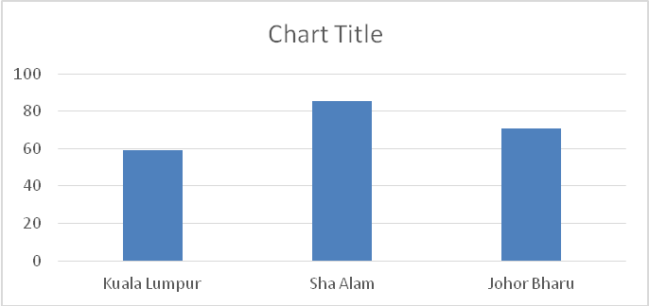
Source: Magistrate Court Cause Book Print, Kuala Lumpur, Sha Alam, and Johor Bahru 2014-2015

The comparative disposition rates are as follows: Sha Alam Magistrate Court is at the average rate of 85.28 days (2.8 months), Johor Bahru Magistrate Court at 70.69 days
(2.3 months), and Kuala Lumpur Magistrate Court at the average rate of 59.21 days (1.97 months). To sum up the three magistrate courts the average disposal is 71. 7 days (2.39 months). It is commendable for Kuala Lumpur the shortest average speed of disposal rate is attributed to attendance of the parties in court session and outright decision on the merits rendered by the magistrate. Whereas, the longest average speed disposal rate of Sha Alam and second highest Johor Bharu are attributed to the absences of parties for cases resolved in the judgment default. The magistrate extends time in re-setting of the hearing to give ample chances and time for the defendants to appear in court and eventually resolve the cases in judgment default. However, it delays the litigation duration period to more than two months both for Sha Alam and Johor Bharu.

The Small Claims Procedures which is at its 30 years of implementation and as average disposition rate of 2.39 months, posts a challenge needed to be addressed to enhance the speed of disposal of cases involving a meager amount of RM 5,000.00. This will quantify whether the mechanism can be improved to ensure efficiency and effectiveness since the highest court resolution is default judgement at 40.8% in Malaysia. This can be attributed to the persistent absence of the defendants that derailed the court proceedings, and would be relative to the information awareness of the intention of Small Claim Procedures to the people. Information dissemination is parallel to the effectiveness of the program. The procedure is sequentially organized and magistrates are efficient. However the disparities of the outcome enabling people to settle civil actions among themselves are high their absences in magistrate session results to the judgment default. The Malaysian Small Claims Procedures amendments are commendable for the precise forms in every stage of the mechanism. However, low public information awareness results to spoilage of the good mechanism. The public failed to use the good mechanism due to the failure to transmit the information that judicial system were given them the structure without legal cost. Giving the best mechanism will be futile without information dissemination.
Malaysian Small Claim Procedure is in its 30th year of implementation and thorough amendments have been made under the Rules of Court in 2012. In this regard, Malaysia has more lessons to teach that would be beneficial for the other Southeast Asian countries which have just adopted the program, like Indonesia and Philippines.

Malaysia has achieved the zero backlogs of the court dockets in the computerization and advancement of the Judicial technological and modernization of the system. This is an exceptional success in the Judicial Reform initiatives while other developing countries are still struggling to implement all their blue print for Judicial Reform programs.

Malaysian Judiciary achievement is challenged to reach out to the people who never knew what is e-filing, e-court and the like. The modernization and success of its Judiciary system becomes real which are inclusive of every Malaysian citizen specifically the unschooled and the marginalized in the society. The information dissemination reforms the image of the judiciary in the interest of granting equity justice rather than punitive justice.

The essential duty of the state is to revitalize the information dissemination of Small Claim Procedures to an ordinary laborer, rank and file employee, market vendor, consumer, and the like. This mechanism affirms that boast their morals, as indeed the government secures and protects them. This information would be life changing to every person who will be empowered to assert his rights because it is, logical to say that “no publication of the privileges results in minimal appreciation and utilization”. No matter how grandeur the purpose and goal of any law, but without knowledge of the people for whom it was created is just like the state has never created the benefits for the people. In so doing, it emerged that the Small Claims Procedure achieved its aims to enable the ordinary people asserting and instituting by themselves legal mechanism to secure fast and low cost litigation of cases. It is commendable in adopting Small Claims Procedures and to address the lack of the information dissemination through TV, radio and social media accessible to everybody rural and urbanized Malaysian communities, in simple presentation and language understandable by the public what, when and how to do process. The public needs to be re-oriented of the magistrate as humane rather than fearful. This is to achieve the goal of enabling and empowering Malaysian people through the Small Claims Procedures. The effectiveness and efficiency of the program will require that the Magistrate both legal and psychological skills training to increase the compromise agreement among parties especially to the highly urbanized cities like Kuala Lumpur that eventually decrease the litigation time of the magistrate. It was identified that a separate Magistrate is needed to handle Small Claims Procedure since it demands tedious time for the magistrate to trench out issues among the parties involved. This is to secure that proceedings are handle diligently without beating against time that minimize hump hazard settling of parties’ disputes which eventually create doubt and suspicion of magistrate fairness. To quote Chief Justice Hewart “justice should not only be done, but should manifestly and undoubtedly be seen to be done”. The real test of likelihood of bias existed is determine by the reasonability left on the minds of the aggrieved party or the public at large.(Metropolitan vs. Lannon, 1969). The evaluation mechanism of the program is necessary to verify the effectiveness and efficiency of Small Claims Procedure mechanism to the end user responsive to the needs of the public in the modernization and complexity of the transactions in the society.

Table 6
Comparison of the feasibility, viability and effectiveness of Small Claims Procedure mechanism in Kuala Lumpur, Sha Alam and Johor Bharu.

District  Magistrate | Public  Accessibility | Average Days  Case Resolution | Resolution of  Cases  Highest  Percentage | Resolution of  Cases  Lowest  Percentage
Kuala Lumpur | Accessible to  Public Transportation  Bus/ LRT/ Taxi/Car | 59.2  (1.97 months) | Decision on Merits  51.6% | Compromise  4.1 %
Sha Alam | Accessible by Taxi/ or Car | 85.3  (2.84 months) | Judgment Default  46.4 % | Decision on Merits  14.3%
Johor Bharu | Accessible by Taxi/ Car | 70.7  (2.35 months) | Compromise  54.3 % | Decision on Merits  20.0%
Source: Magistrate Court Cause Book Print, Kuala Lumpur, Sha Alam, and Johor Bahru
2014-2015

Table 6 shows that Kuala Lumpur Magistrate a highly urbanize district its location has effects on the viability of the parties to attend court session. Since the court is 6.8 km accessible public to the LRT Sentral station. It reflects on the highest court resolution based on the merits of case with the lowest average days of 1.97 months.

Sha Alam Magistrate is situated at the city and the state capital of Selangor, Malaysia and situated within the Petaling District. It is 6.9 km distance from the Bus Station to the Magistrate Court and it requires taxi or private vehicle for the public to transact business. This factor contributes to the public inaccessibility in attending court session posting highest judgment in default and longest average days of 2.84 months.

Johor Bahru is located at the capital of the Malaysian state of Johor, sits at the southern tip of the Malay Peninsula. It is 7.2 km distance from Larkin Sentral Bus Station to the Magistrate Court and taxi or private vehicle is needed to appear in court hearing. The expensive transportation influence parties to enter in compromise agreement turn out as the highest in the court resolution.

In an interview with the court staff brochures are limited to address public awareness as well as litigant is not reading even written in local dialect. The court staffs are assigned to give extensive explanations to the parties’ queries in the office.

The diagram of the steps will address the non-reader public of the rules in paragraph forms. It will lessen the most frequently asked attended by the court staff everyday to all the parties inquiring court. The diagram will visualize the mechanism and procedures by the public through illustrations eventually understand it.

Figure 3
Model of Small Claims End-User Friendly
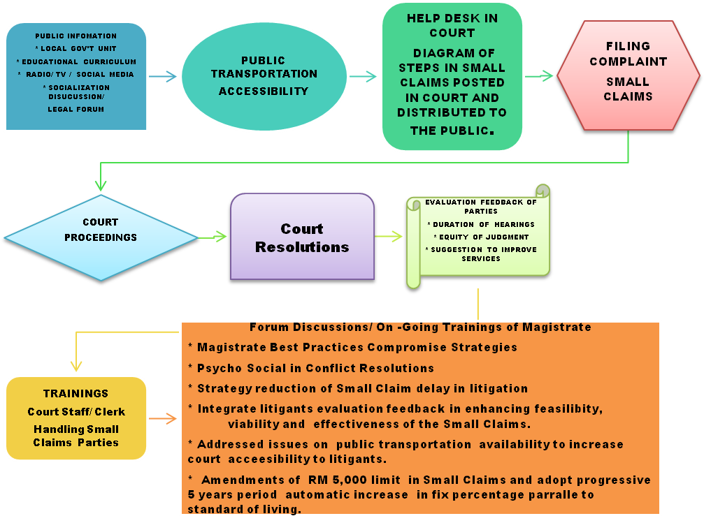

The model Small Claims User-Friendly adopts simple terms helpful and understandable by laymen. The dynamic information dissemination through the local government unit, radio, television, social media, integrated in the education curriculum of Malaysian Politics and governance, socialization employer and employee, business sectors and other legal forums. The public transportation route to court needs to increase public accessibility. The help desk and printed visual diagram posters the Small Claims procedure is necessary for public information signage. This would be a lay man’s guide what to do and how to do in pursing their rights without assistance of advocate. The feedback mechanism of Small Claims litigants is important the unwritten and unspoken opinions of the public that best source of wisdom to evaluate the realities of efficiency and effectiveness of the rule mechanism to end-users which were crafted by legislators to the public. In addition, psycho social training of staff and clerk responsive to the needs of the unschooled and marginalized public to resolve conflicts through compromise agreements and secure attendance in court that eventually hasten the disposal of cases. The forum discussion and on-going training of the Magistrates most sought recommendations to share the court’s best practices, psycho social approaches, strategies to reduce delay in cases of parties absences and helpful to ensure efficiencies of their skills in handling the individual plaintiff who are unassisted by advocates.

The Small Claims amount needs to be amended and adopt progressive scheme every 5 years responsive to the economic feasibility of the public. The Small Claims Cases is recommended to segregate from other regular cases which requires substantial time of the Magistrate and the most difficult to handle are parties who unassisted by advocates based from the observation of the magistrate.

The model of Small Claims end-user friendly were craft based from litigants, court personnel and magistrate observations and interview in the conduct of the this research suggests to enhance feasibility, viability and effectiveness of the Small Claims of Malaysia.

Conclusion

The results of the study would be beneficial for the court to improve efficient and effective case management responsive to public needs.

In this regard, Treaties of the Government secures that people rights to life, liberty and property become independent of any laws in the society. In return, the state needs to protect unconditionally that these rights in the attaining stable, comfortable lives, liberty and property. The government exists by the consent of the people in order to protect the rights of the people. (Locke, 2016).

References:

Ahmad, Rajasingha (2001) Case-Management as a Method of Resolving Problem, Asian Law Series No. 4 page 12

Ahmad, S. (2001) The Malaysian Legal System, Legal Practice and Education, Institute of Developing Economies-Asian Law Series No. 4, Japan
Ahmad, S. (2002) Dispute Resolution Process in Malaysia , Institute of Developing Economies , Asian Law Series No. 17 , Retrieved on May 23, 2016, from the Website,http://www.ide.go.jp/English/Publish/Download/Als/pdf/17.pdf
Albers, P. (2003) Evaluating Judicial Systems: A Balance between Variety and Generalisation, CEPEJ, Strasbourg. http://www.coe.int/t/dghl/cooperation/cepej/evaluation/2012/Rapport_en.pdf
Alderman, R. (2009) “How to Sue in Small Claims Court, “The People’s Lawyer, University of Houston, Law Center, Retrieved on April17, 2017, from the Website, http:// www.peopleslawyer,net/smallclaims/&gt;
Armytage, L. (2012) Reforming Judiciary: A voice of fairness in Asia, Cambridge University Press, Australia
Baldwin, J (1997) Small Claims in the Country Courts in England and Wales, Oxford: Clarendon Press, p. 10

Business Dispute, Retrieved on May 1, 2017 from the Net WebSite http://irep.iium.edu.my/8186/1/2006_-_Small_claims_court%27s_procedure_for_small_claims_business_dispute.pdf

Cappelletti, M.(1970) California Law Review: Judicial Review In Comparative Perspective, October 1970 Vol. 58 No. 5

Feliprada, G. (2014) Justice for the Poor: How Adequate are the Legal Reforms in the Philippines?,Yuchengco Center, De La Salle University, Philippines
Halim, T Judicial Independence, Accountability, Integrity, and Competence – Some Aspects of Malaysian Position Retrieved on July 14, 2013 from the Website http://jrn21.judiciary.gov.ph/forum_icsjr/ICSJR_Malaysia%20%28D.%20H alim%2 9.pdf
Hewart, CJ (1924) R vs Sussex Justices, ex p Mc Carthy 1 KB 256 AT 259.

Jawan, J. (2013), Malaysian Politics and Government, Pacific Press SdnBhd, Selangor, Malaysia p. 133

Jalil, J. et. al. (2015) Civil Procedure Malaysia, Retrieved on May 30, 2017 from the Net Web http://irep.iium.edu.my/47802/4/IEL_Kluwer_Civil_Procedure_(Malaysia)-Completed.pdf
Kamarudin, A. (2006) Small Claims Court’s Procedure for Small Claims
LexisNexis (2015) Malaysian Court Practice Trial Court 2, Malaysia SdnBhd

Lillo, R ( 2016) Access to Justice and Small Claims Court supporting Latin America, Revista Chilena de Derecho, Vol.43,pp. 955-986, Retrieved on April 13, 2017 from the Net Web http://dx.doi.org/10.4067/S0718-34372016000300008

Locke, J. (2016) Treaties of the Government, Retrieved on May 28, 2017 at the Net Web https://plato.stanford.edu/entries/locke-political/

Malaysia Court Backlog and Delay Reduction Program (2011) Retrieved on December 28, 2012 from site http://www.kehakiman.gov.my/sites/default/files/document3/Teks%20Ucap an/WORLD%20BANK%20REPORT%20FINAL.pdf
Malaysia Magistrate Court Cause Book Print, Kuala Lumpur, Sha Alam, and Johor Bahru 2014-2015
Malaysia Judicial Structure, Retrieved on May 25, 2016, from the Website http://www.kehakiman.gov.my/sites/default/files/document3/POJ-LAPORAN%20TAHUNAN/ENGLISH/IA-PT2.pdf
Malaysian Judicial History, Retrieved on May 28, 2018 from the Net Web http://www.ubplj.org/index.php/dlj/article/viewFile/156/181
Malaysia Rule of Court 1980, Retrieved on May 28, 2017 from the Net Web http://globalclassactions.stanford.edu/sites/default/files/documents/Malaysia_National_Report.pdf
Metropolitan Properties Co (FGC) Ltd vs Lannon (1969) 1 QB 577, 3 All Er 304, CA (Eng).
Yahya, A. The Dangers of Debt, Retrieved on May 31, 2017 from the Net Web
http://en.islamway.net/article/8834/the-dangers-of-debts
Messick, R. (1999) Judicial Reform and Economic Development: A Survey of the Issues, The World Bank Research Observer, Vol. 14. No. 1 p.117-136
Mohamed.A. (2015) Court Reform Programs: The Malaysia Experience, Retrieved on May 1, 2017 from the Net Web (http://sas-space.sas.ac.uk/6375/1/Azahar_bin_Mohamed_Court%20Reform_Programmes.pdf
Subordinate Courts Rules 1980, (2007) International Law Book Services, Syarikat Percitakan Ihsan 43300 Balakong, Selangor.
The Commissioner Revision of Laws, (2006) Acts 256 Debtors Act of 1957, Retrieved on May 30, 2017 from the Net Web https://simplymalaysia.files.wordpress.com/2011/10/act-256-debtors-act-1957.pdf
Wang, C. (2000) Malaysian Judiciary blinks Retrieved Net Web http://www.wanglaw.net/files/Malaysia22.pdf

Yu, Y. The Adversarial vs. Inquisitorial System, Retrieved on May 7, 2017 from the Net Web http://www.cbl-international.com/docs/csu0714/the-adversarial-vs-inquisitorial-system.pdf

